Lens bend

Light can bend when it enters or leaves a glass block.

A lens is a specially shaped glass block.
Most lenses are circular.
The flat version of each lens shows its shape more clearly.

a. Which lens do you think bends light the most?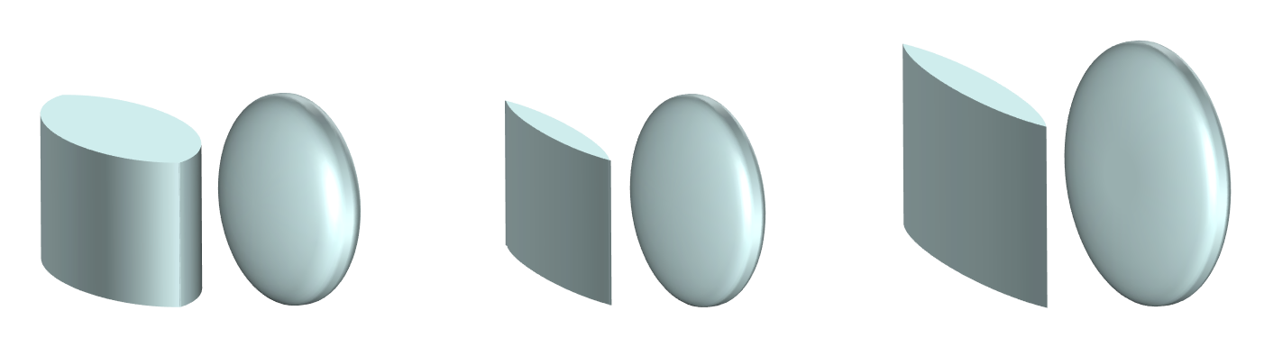
A B C

b. Why do you think this lens bends light the most?
Put a tick (✓) in the box next to the best answer.
A | Light takes longer to move through the lens
B | More light can pass through the lens
C | Light hits the lens at bigger angles
D | There is more lens to interact with the light

Physics > Big idea PSL: Sound, light and waves > Topic PSL3: Making images > Key concept PSL3.2: Refraction and lenses
Diagnostic question
Lens bend

Overview
Learning focus: | All light from each point of an object that passes through a converging lens is bent (refracted) to a corresponding point in a sharp image.
Observable learning outcome: | Explain how the shape of a lens enables it to focus light.
Question type: | Two-tier multiple choice
Key words: | Refract, lens, lenses

What does the research say?
Students often think of an image as a physical replication of an object which can travel, remain still or turn as a whole. They may ascribe active powers to lenses to manipulate images in order to explain how they appear in a particular way on a screen (Galili and Hazan, 2000). For example, Galili and Hazan (2000) found that over half of 14- to 15-year olds (n=64) thought that when a converging lens is removed, the inverted image it forms is replaced by an image the correct way up. These students are applying the misunderstanding that a lens actively flips an image that is already there.
Students can use ray boxes with three slits to observe how cylindrically curved lenses refract light rays (Tear, 2011). This is helpful in showing how light rays are refracted (bent) by a lens. Light is refracted differently from each part of the lens because it hits the lens at different angles. It has been suggested that this learning point can be made clearer by showing how a number of prisms can be used to refract light in the same way as the lens (Ziegler and Priemer, 2015).
Ways to use this question
Showing students different lenses as an introduction to this question can help to eliminate misinterpretation of the lens pictures.
Students should complete the questions individually. This could be a pencil and paper exercise, or you could use an electronic ‘voting system’ or mini white boards and the PowerPoint presentation. The follow on question will give you insights into how they are thinking and highlight specific misconceptions that some may hold.
If there is a range of answers, you may choose to respond through structured class discussion. Ask one student to explain why they gave the answer they did; ask another student to explain why they agree with them; ask another to explain why they disagree, and so on. This sort of discussion gives students the opportunity to explore their thinking and for you to really understand their learning needs.
Differentiation
You may choose to read the questions to the class, so that everyone can focus on the science. In some situations it may be more appropriate for a teaching assistant to read for one or two students.
Equipment
For the class:
- Selection of cylindrical and circular converging lenses of different curvatures.
Expected answers
- A: Lens A bends the light the most.
- C: Light hits the lens at bigger angles.
How to respond - what next?
It is likely that some students will select lens A because (A) light takes longer to move through the lens, or lens C because (D) there is more lens to interact with the light. These students are likely to think that the direction of the light is changed by the glass, rather than by the transition across the air-glass boundary. Some may consider the lens actively turns an image that passes through it.
A few students may select lens C because more light can pass through it. In terms of geometry, if all lenses bend light to the same point, the larger lens will need to bend light more to reach this point from its outer edge than a smaller lens.
If students have misunderstandings about how the shape of a lens affects how much it bends light, it can help students to use ray boxes to complete an investigation to compare different lenses. The usual investigation uses a ray box with three slits to shine three parallel narrow beams of light through a range of cylindrical lenses, and for students to draw and compare how far the narrow beams take to cross at a focal point.
Although the investigation with three parallel narrow beams hitting a lens shows how a lens bends light, it does not show how a lens makes an image. Indeed, if used on its own this investigation can easily introduce misunderstandings about how lenses form images. It is therefore recommended that this investigation is followed by a demonstration or class experiment to clarify how an image is formed by a converging lens. The following BEST ‘response activity’ could be used to do this:
- Response activity: Getting focused
Acknowledgments
Developed by Peter Fairhurst (UYSEG).
Images: Peter Fairhurst (UYSEG).
References
Galili, I. and Hazan, A. (2000). Learners' knowledge in optics: interpretation, structure and analysis. International Journal of Science Education, 22(1), 57-88.
Tear, C. (2011). Sound, light and waves. In Sang, D. (ed.) Teaching secondary physics. London: Hodder Education.
Ziegler, M. and Priemer, B. (2015). From the pinhole camera to the shape of a lens: the camera-obscura reloaded. Physics Education, 50, 706-712.

